Central Tendency Assignment
Output Result:
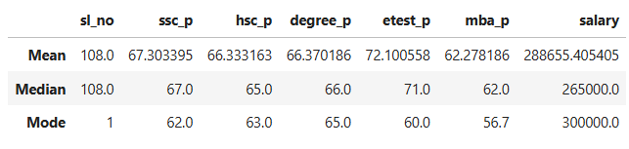
Summary of Student Placement Analysis

Mean Analysis (Including Outliers)
- Students obtained an average score of 67.30% in the SSLC examination.
- Students obtained an average score of 66.33% in the HSC examination.
- Students obtained an average score of 66.37% in their degree examination.
- Students obtained an average score of 72.10% in the Entrance examination.
- Students obtained an average score of 62.27% in the MBA examination.
- The average salary offered to the students is 288,655.40.

Median Analysis (Excluding Outliers)
- The median SSLC score among the students is 67%.
- The median HSC score among the students is 65%.
- The median degree score is 66%.
- The median Entrance examination score is 71%.
- The median MBA score is 62%.
- The median salary received by the students is 265,000.

Mode Analysis (Most Frequently Occurring Values)
- The most frequently scored SSLC mark is 62.
- The most frequently scored HSC mark is 63.
- The most frequently scored degree mark is 65.
- The most frequently scored Entrance exam mark is 60.
- The most frequently scored MBA mark is 56.
- The most frequently offered salary is 300,000.

Overall Performance
Overall, the students’ performance across all examinations is above average.

